**APRIL 2025 Autism**

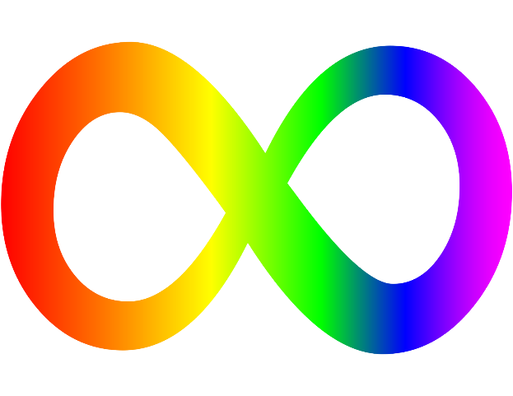 **Awareness**

**Month**

* [What is autism spectrum disorder?](https://www.nimh.nih.gov/health/publications/autism-spectrum-disorder#part_6150)
* [What are the signs and symptoms of ASD?](https://www.nimh.nih.gov/health/publications/autism-spectrum-disorder#part_6152)
* [What causes ASD?](https://www.nimh.nih.gov/health/publications/autism-spectrum-disorder#part_6154)
* [How is ASD diagnosed?](https://www.nimh.nih.gov/health/publications/autism-spectrum-disorder#part_6156)
* [What treatments and services are available for ASD?](https://www.nimh.nih.gov/health/publications/autism-spectrum-disorder#part_6158)
* [Where can I learn more about ASD?](https://www.nimh.nih.gov/health/publications/autism-spectrum-disorder#part_6161)
* [What are clinical trials and why are they important?](https://www.nimh.nih.gov/health/publications/autism-spectrum-disorder#part_6163)
* [For more information](https://www.nimh.nih.gov/health/publications/autism-spectrum-disorder#part_6441)